**ANUSHA SAAD**

**19K-0281**

**SECTION: H**

**COAL ASSIGNMENT 3**

Recursion program logic:

Now a day’s people give their loved one a gift and to make it a bit more interesting, what they do is that they take a big box, but if you open it there is smaller box inside. This keeps on going until you reach the smallest box. Now they have to paint these boxes but if they paint the first box that is the largest one they cannot touch the box because it is wet, so they need to wait until the box is dried. This will take a lot of time. What should they do then? They open the first box and then the second one until they found the smallest one. Paint the smallest box and then the second smallest and then repeat until you’ve painted all of them.

* I’ve assumed that the smallest box is of size 2 inch.
* The user will enter the size of the biggest box.
* Recursively reaches the smallest box and then start on painting the box and printing a statement once the box is painted.

Runtime Requirement:

* N can’t be a negative or an odd number
* N cannot be less than 2 as the fixed size of smallest box is 2.

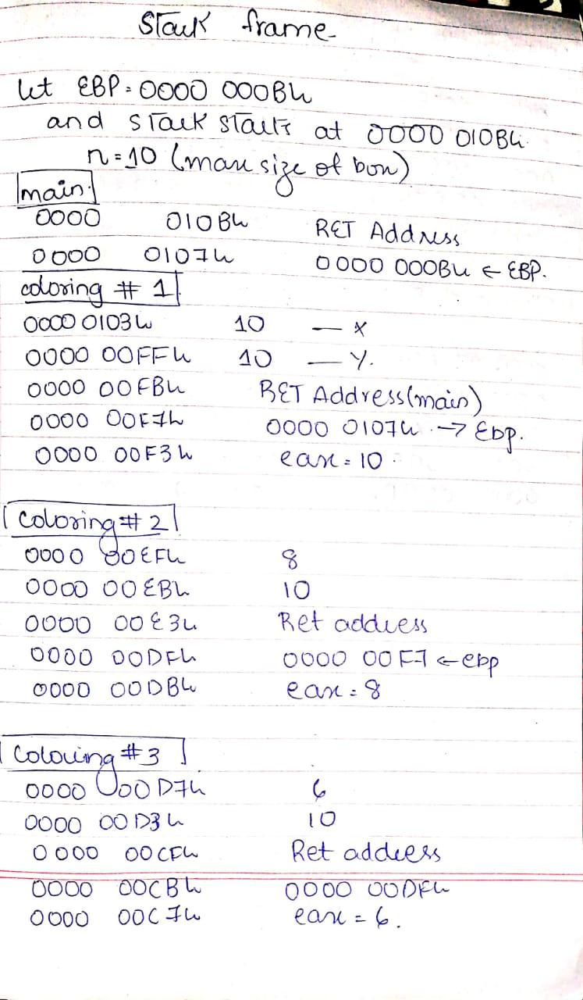

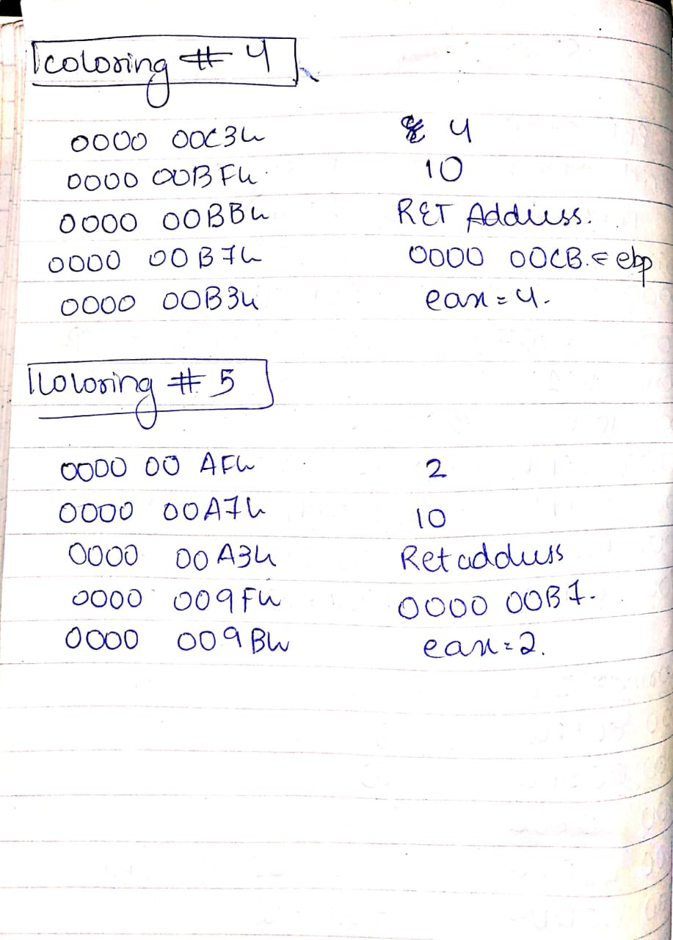

ASM CODE:

include irvine32.inc

.data

msg byte "enter the size of box: ",0

msg1 byte "BOX Painted of size ",0

msg2 byte "INCH",0

n dword ?

sum dword 0

.code

coloring PROTO X:DWORD, Y:DWORD

main PROC

mov eax,0

mov edx,offset msg

call writestring

call readdec

mov n,eax

add eax,2

push n

INVOKE coloring,n,eax

exit

main ENDP

coloring proc, X:DWORD, Y:DWORD

mov eax,x

cmp eax,2 ;the smallest box is of 2 inch

jz l1

jnz l3

l1:

cmp eax,Y

jz l4

jnz l2

l2:

add sum,eax

mov edx,offset msg1

call writestring

call writedec

mov edx,offset msg2

call writestring

call crlf

add eax,2

jmp l1

l3:

sub eax,2

INVOKE coloring,eax,Y

l4:

;mov eax,sum

;mov edx,offset msg1

;call writestring

;call writedec

call crlf

jmp l5

l5:

ret

coloring ENDP

END main